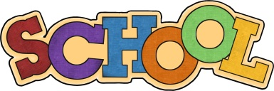

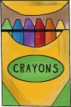
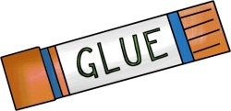
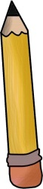

PENN ELEMENTARY SCHOOL
703-590-0344

2nd GRADE SUPPLY LIST
2023-2024
Welcome! We are excited to have you join us this year.
LABEL ALL ITEMS WITH CHILD’S NAME

2 dozen #2 pencils-SHARPENED
1 sturdy folder with pockets (any solid color)
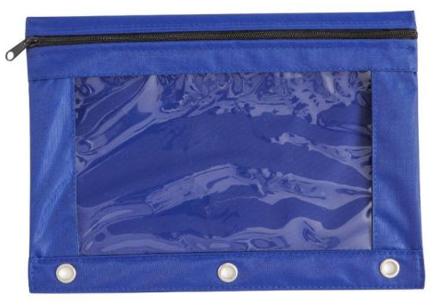
1 composition books (black and white) (WIDE-RULED, No Spirals please)
2 boxes of 24 crayons
1 LARGE Zippered Pouch or pencil box
(for pencils and supplies)
2 pk of 12 glue sticks
1 pairs of scissors
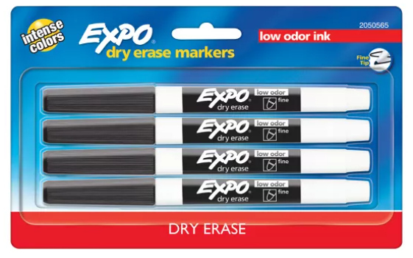
1 clipboard – labeled with student name
2 pack 4 dry erase markers (thin, black)
1 pk of pencil top erasers

Boys – gallon bags (50 ct)
Girls – sandwich bags (50 ct or quart size)

*It is easier to buy extras now (during sales) for when your child needs to replenish items during the year. Also, students can reuse supplies like their clipboard, scissors and pencil box from first grade if they are still in good condition.

Elliot F. Bolles, Ed.D, Principal June 2023

